Digital Literacy Project Report
Name: Shikhar Yadav
Course: CSE0001 Digital Literacy
University: VIT Bhopal University
Program: B.Tech Computer Science
Year: 1st Year

Introduction
Digital literacy plays an important role in helping students effectively use modern technology for academic learning and communication. Through this project, I explored several digital platforms, practiced professional email writing, and learned about online safety and cybercrime awareness. These activities helped me improve both my technical knowledge and professional communication skills.

Task-1: Infographic on Digital Literacy
Reflection
While preparing the infographic, I understood how digital literacy supports safe and responsible internet usage. I included topics such as online safety practices and email communication because they are essential for students today. Designing the infographic also helped me improve my ability to present information visually in a simple and organized manner.

Task-2: Digital Portfolio Setup
Platforms created:
- GitHub Profile
- LinkedIn Profile
- HackerRank Profile
Reflection
Creating accounts on professional platforms helped me develop my digital identity as a student. Updating my GitHub profile allowed me to showcase my learning progress, while LinkedIn helped me build a professional network. HackerRank supported my coding practice and problem-solving skills. These platforms will be useful for internships and career opportunities.

Task-3: Platforms Activity
Activities completed:
- Solved a beginner coding problem on HackerRank
- Designed a Digital Literacy Awareness quiz using Google Forms
- Collected responses and reviewed them in Google Sheets
Reflection
This activity helped me understand how online tools can be used for both learning and collaboration. Creating the Google Form improved my knowledge of survey creation and response analysis. Solving a coding problem strengthened my confidence in using programming platforms.

Task-4: Email Etiquette and Professional Communication
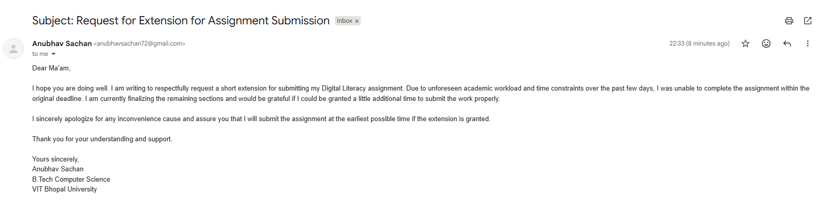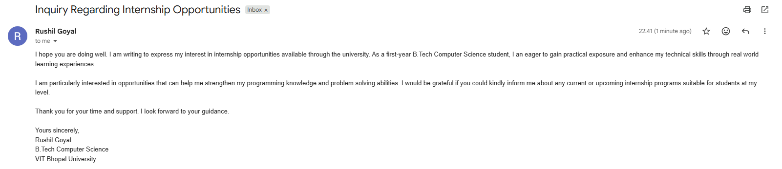

Reflection
Through this task, I learned how to write formal emails with proper subject lines, greetings, and structured content. I realized the importance of maintaining clarity and professionalism while communicating with faculty members and coordinators through email.

Task-5: Cybercrime Awareness Case Study
Case Study: UPI Payment Request Scam
With the increasing use of digital payment applications, UPI-related fraud cases are rising across India. One common type of fraud involves fake payment request approvals. In one such incident, a college student tried to sell a used electronic device online. The buyer contacted the student and claimed that he had sent the payment through UPI. Instead of transferring money, the fraudster actually sent a “collect request” and asked the student to approve it to receive the payment.
Believing the request was required to accept money, the student entered the UPI PIN and approved the request. Within seconds, money was deducted from the student’s bank account. The fraudster immediately stopped responding and blocked further communication. Later, the student realized that approving unknown collect requests can result in financial loss.
This case highlights the importance of understanding how UPI transactions work. Users should carefully check whether they are sending or receiving money before entering their UPI PIN. Awareness of such scams helps individuals avoid becoming victims and promotes safer use of digital payment systems.
Reflection
Researching cybercrime awareness helped me understand common digital threats such as online payment fraud and phishing attacks. I also learned how prevention methods and reporting portals help users stay protected in digital environments.

Conclusion
Overall, this project enhanced my understanding of digital platforms, safe internet usage, and professional communication methods. These skills will help me perform better academically and prepare for future professional opportunities.

